Instrumentation & Controls Course
[IC]

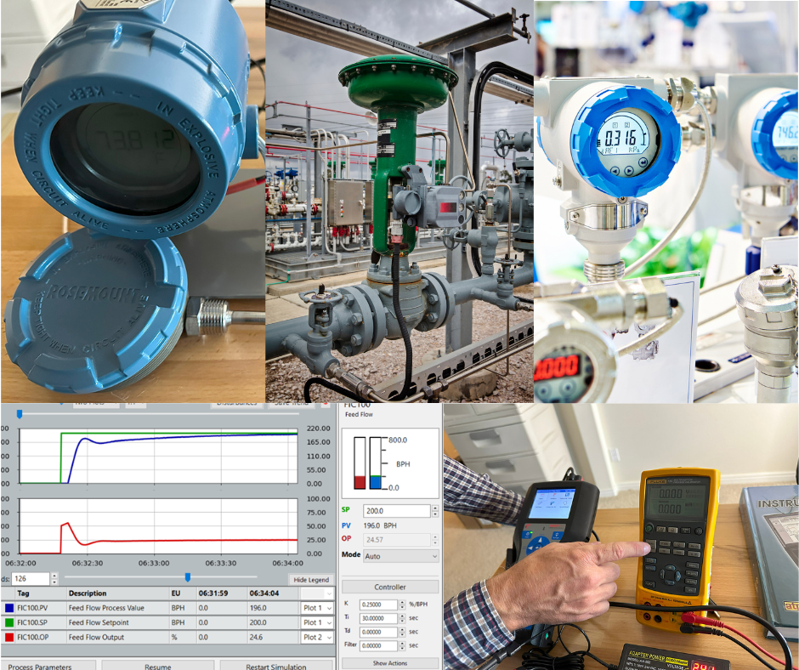
Instrumentation
&
Controls
Course

Course Overview
Length: 4-days (32 hrs)
Hands-On: 50%
Target Audience: Personnel who work with or need to better understand industrial Instrumentation & Control concepts and systems (Developing Technicians, Engineers, Process Control Techs, and I&C Managers and Supervisors)
Summary Description: This course introduces students to the core fundamentals involved with modern industrial instrumentation, measurement, calibration, and controls. This course places heavy emphasis on the topics that are often misunderstood in industry and which cause many of the maintenance, troubleshooting, and plant performance problems.
This course is useful for anyone from a mechanical technician or plant operator up to senior instrumentation technicians and engineers needing to better understand the instrumentation associated with their systems. The topics presented are based on decades of expert observations of the problems and mistakes made throughout the instrumentation and controls fields.
Each student attending our public I&C courses will receive a 700-page hard-cover textbook for use in the course and detailed reference well after the course (Instrumentation & Process Control by Franklin Kirk: $200 retail cost). Instead of attempting to cover all topics of an I&C program that would require hundreds of hours of instruction within a short 3-4 day program, our I&C course focuses on the core topics that will enable the students to make good, effective use of the provided text reference as needed, so they can continue to learn and grow over time and solve whatever problem arises.

Course Agenda:
Day 1
- 4-20mA control loop and learn how to effectively test and troubleshoot analog IO problems.
- SMART transmitter concepts and operation (gain familiarity with the common functionality, mistakes, and misconceptions of SMART instrumentation and differences with older instrumentation and how it impacts maintenance programs and procedures)
- Process & instrument diagram basics (P&ID's)
- Understanding calibration standards (NIST, etc.)
- Instrument calibration concepts, including common calibration errors, best practices for calibration programs, etc.
- Test and calibration equipment usage and tips (process meters, calibrators, and HART communicators)
- Pneumatic devices (I/P, etc.)
- Temperature measurement systems
DAY 2
- Understanding and resolving instrumentation signal noise
- I&C calibration & maintenance programs (including common mistakes and misconceptions)
- Pneumatic and hydraulic pressure concepts (key concepts applied across the I&C field)
- Pressure measurement systems
- Level measurement technologies
- DP-based level measurement issues
- Flow measurement technologies
- DP-based flow measurement issues
- Common analytical instrumentation basics (pH, conductivity, etc.)
DAY 3
- Typical plant control system architecture and related issues
- Safety Instrumented System (SIS) basics and testing, per IEC 61511
- Control & isolation valve basics (issues, problems, tips & tricks)
- Control actuators & positioner basics (common mistakes, faults, errors & troubleshooting)
- Other final control elements (dampers, VFD, VSD, mechanical drives & clutches, etc.)
- Importance of proper instrument signal filtering and proper adjustments
- Introduction to feedback control and associated terminology and concepts
DAY 4
- PID loop controller functions and features
- Understanding control loop objectives, challenges (and compromises)
- Introduction to PID loop tuning
- Risks, hazards, and precautions when working with process control systems
- Troubleshooting common control loop problems (deadtime and lag, noise, actuators and control elements, nonlinearity, operating outside effective range of control, reset windup/process saturation, etc.)
- Introduction to typical process control strategies and applications
- Safety and Shutdown system basics

Hands-On Exercises (only major items or group titles listed):
This course is over 50% hands-on training. The course is designed so that students will run into numerous real-world ‘planted’ problems and issues and go about resolving them. Students will see various issues and problems first-hand, and will see how I&C theoretical concepts align with reality and help with solving problems.
The labs for this course are focused on the areas that are typically harder to learn and/or that are more critical and often misunderstood. Because of the practical, real-world approach in the key areas, our I&C course produces a more observable boost in practical skills and long-term abilities than typical slide-show or lecture oriented courses.
- Some of the hands-on exercises for this course include:
- 4-20mA loop concepts and troubleshooting
- Smart transmitter functionality (how they are different from old analog transmitters and why they must be treated very differently).
- Transmitter damping labs
- RTD testing, calibration, and mistakes lab
- Thermocouple testing, calibration, and mistakes lab
- Smart transmitter configuration details (including damping, AI trim, AO trim, test outputs, fault settings, alerts/alarms, etc.
- Calibrating transmitters (and common mistakes and problems, and best practices)
- Understanding instrumentation accuracy, errors, tolerances, etc.
- Troubleshooting 4-20mA loops, transmitters, analog IO, scaling problems, etc.
- Level DP troubleshooting and configuration demos
- Flow DP troubleshooting and misconceptions demos
- Simulated control loops setup, tuning, and troubleshooting demos
- Analyze, optimize, and troubleshoot simulated control system performance.
- Perform typical Safety Instrumented Systems proof testing for a SIL-rated instrument function (as applicable)

Student Outcomes (Course Objectives)
- Understand the 4-20mA control loop and how to effectively test and troubleshoot analog IO problems.
- Understand the operation of modern SMART transmitters and gain familiarity with the common functionality, mistakes, and misconceptions associated with them.
- Gain awareness of diagnostic capabilities of modern instrumentation and be better able to utilize it to improve plant performance and reduce downtime.
- Understand instrument and transmitter calibration concepts, including common errors, best practices for calibration programs, etc.
- Learn to utilize common instrumentation test and calibration equipment such as process meters, calibrators, and HART communicators.
- Understand typical HART communications and HART communicators & modems, usage, operation, issues, problems and solutions.
- Understand signal noise and the importance of proper signal filtering (damping) and the safety and control performance problems that incorrect filtering can cause.
- Understand typical instrumentation calibration & maintenance programs and common mistakes and problems.
- Understand the operation and concepts behind typical control valves, actuators, and positioners.
- Understand basics of feedback control and typical methods used (analog, on/off control, integrating/ramping control, PWM, etc.)
- Become familiar with the operation of common types of controllers and control systems used within the instrumentation field and with the typical hierarchy of plant control & shutdown systems.
- Learn the basic concepts behind PID controls and be able to recognize common field-induced problems in process control performance.
- Understand how to troubleshoot each of the following types of common instrumentation performance problem causes (deadtime and lag, noise, actuators and control elements, nonlinearity, operating outside effective range of control, reset windup/process saturation, etc.)
- Become familiar with common process control strategies and methods.
- Understand potential process safety issues and mistakes when working with instrumentation.
- Gain basic familiarity with Safety Instrumented System (SIS) testing, per IEC 61511.

Team / Organizational Benefits:
- Better recognition of problems which leads to solving problems and preventing escalation of errors or problem – which reduces downtime, improves efficiency, and increases safety margins.
- Quicker recognition and correction of mistakes or problems with procedures, control functionality, or designs, resulting in problems being resolved BEFORE they cause problems.
- Improved overall operations (reduce the amount of misconception, mistakes, and assumptions that often occur in the I&C field).
- Enhanced team cohesion – Lesser skilled individuals sometimes hide their weaknesses and use other means to establish a position in the team hierarchy (vs performance). Once they develop strong fundamentals, they are able to learn; able to better communicate with team-mates; and can succeed based on merit and skills vs other approaches. Developing the underlying fundamentals often leads lower performers to shift their energy and efforts into improvement instead of other behaviors that can damage the team dynamic.
- Increased job satisfaction and team morale – Technical personnel derive great satisfaction from ‘being good’ at their jobs. Giving them the skills to troubleshoot and to continue growing boosts job performance and ultimately boosts retention.

