Advanced ControlLogix® PLCs Course
[ACLX]
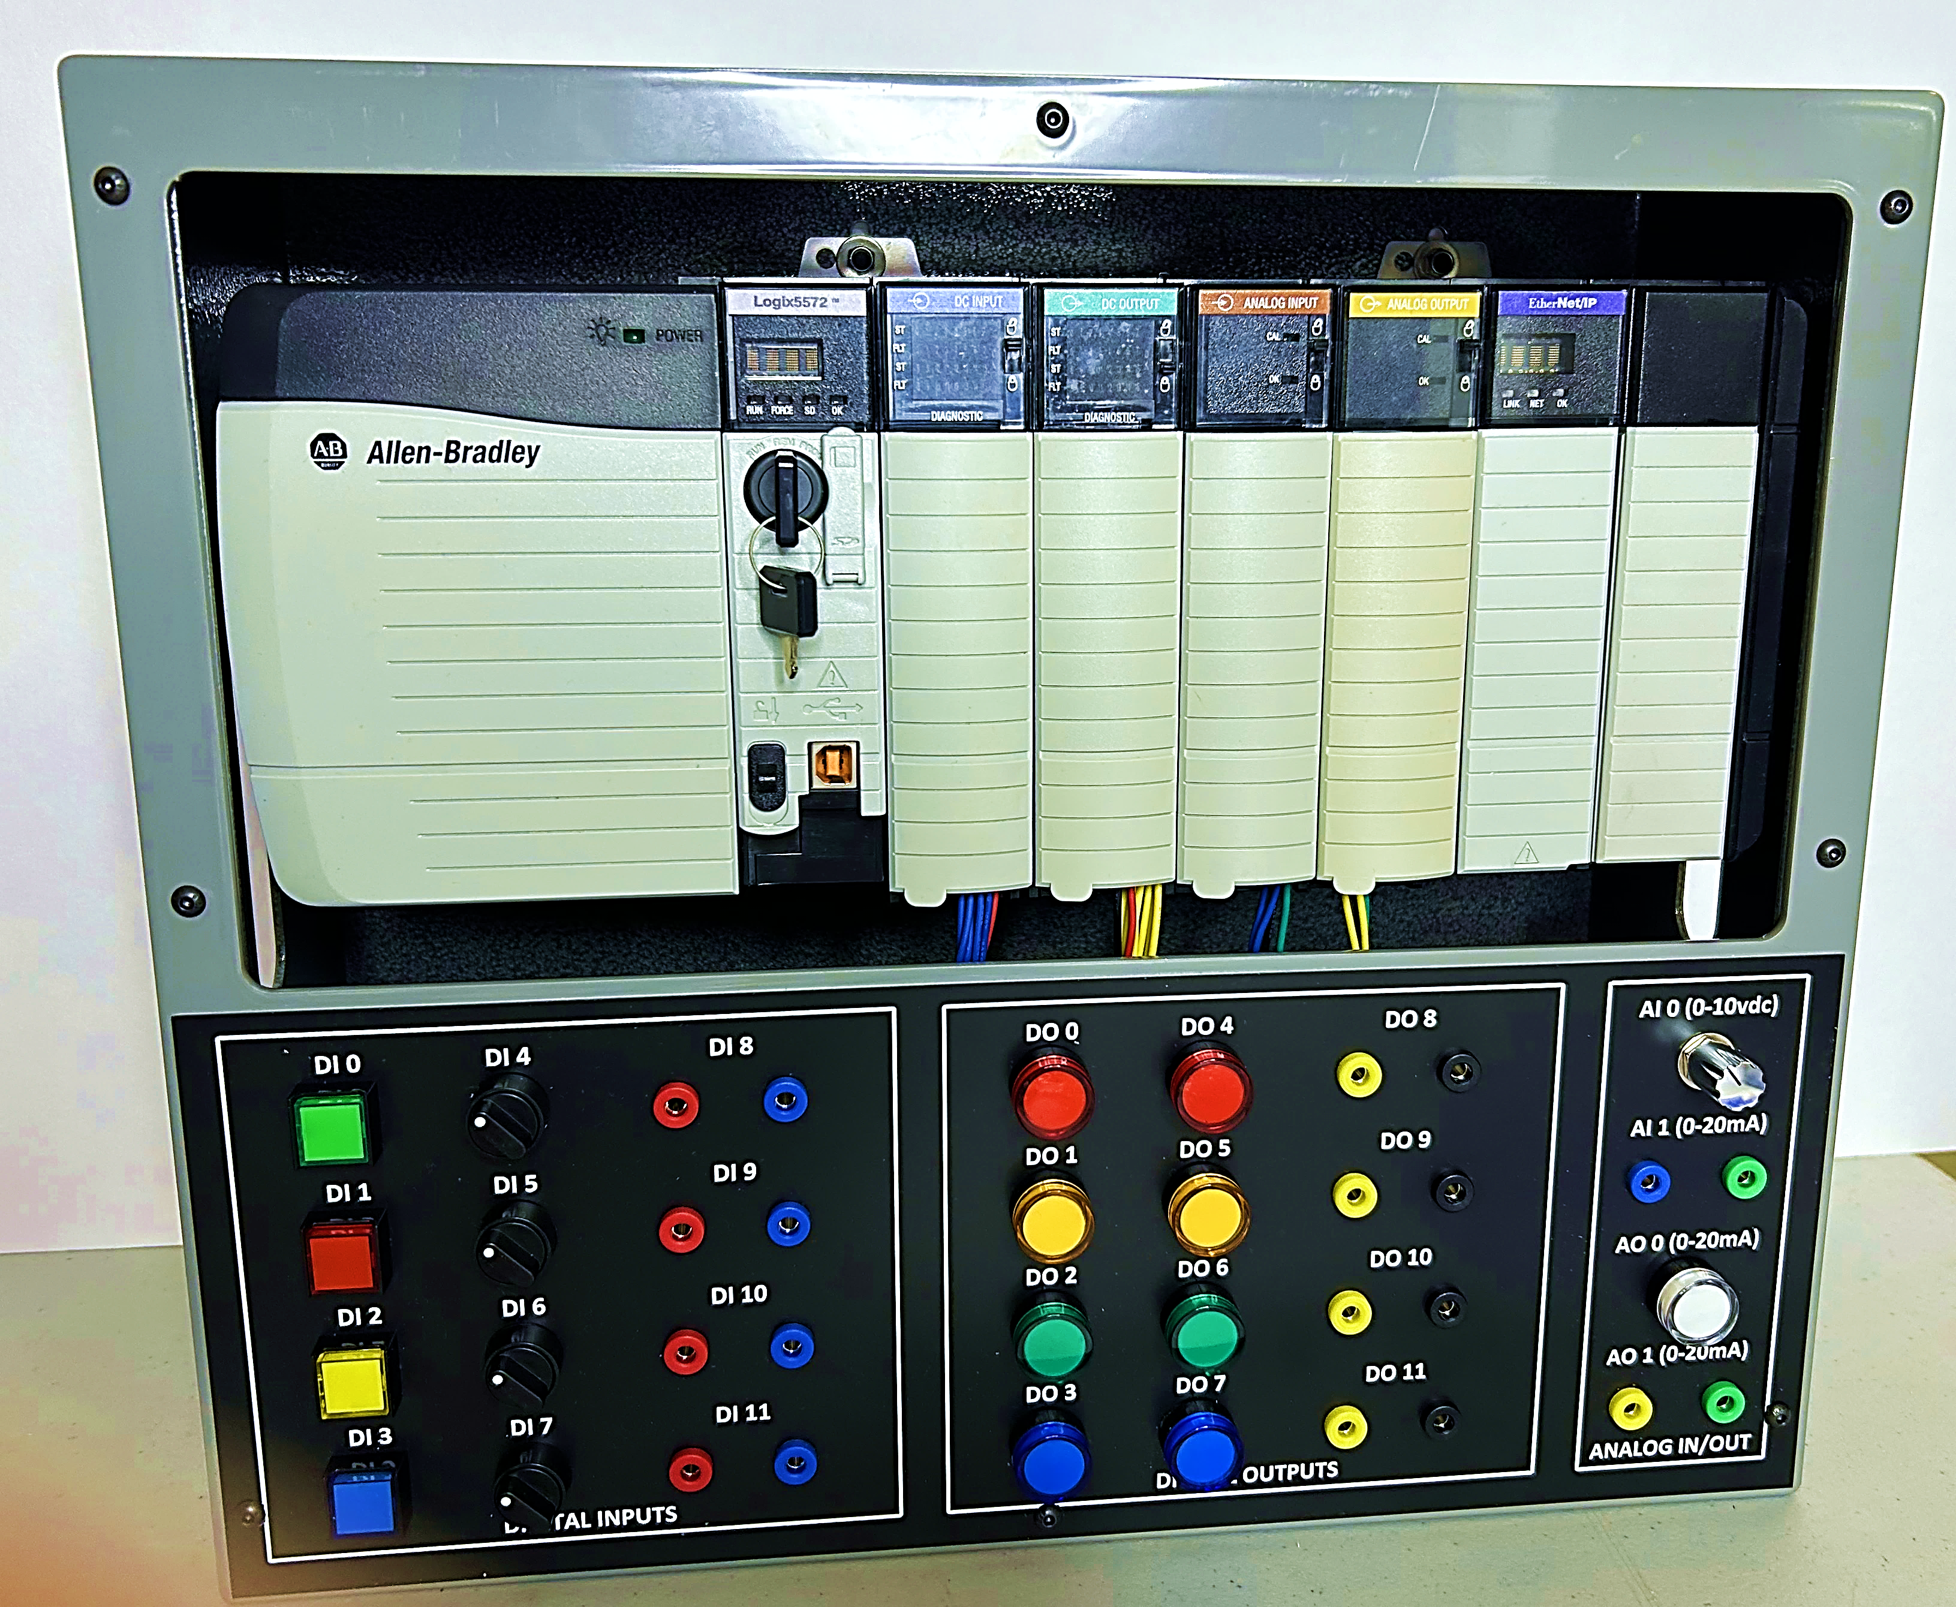
Advanced ControlLogix® PLCs Course

Course Overview
Length: 5-days (40 hrs)
Hands-On: 50%
Target Audience: Personnel with intermediate level knowledge needing to begin doing higher level design, configuration, programming, and engineering oriented work on ControlLogix® systems.
Typical attendees include electricians, instrument technicians, automation personnel, and engineers.
Summary Description: This advanced course is designed for intermediate ControlLogix® practitioners to advance their skills in design, development, programming, and project integration. It covers control system development, creating well-integrated automation systems using ControlLogix® PLCs, and coordinating HMIs with PLC systems. Key learning points include:
- Control System Development: Learn to create effective automation systems using ControlLogix® PLCs and typical HMI systems.
- Engineering Aspects: Focus on programming structure, network layouts, communications, and I/O configurations.
- PLC Project Steps: Understand field component selection, system standards, functional templates, design documents, and troubleshooting.
- Examples and Tips: Gain insights into functions, features, coding, and common mistakes to avoid.
Course Agenda:
Day 1
- Overview of ControlLogix® family and integration devices
- Logix Studio 5000 License options
- HMI systems overview
- ControlLogix® processor functions and monitoring
- Good programming practices
- Starting an automation project
- Program layout and hierarchy
- Program flow details
- Power loss & return functionality issues
- FAULT and STARTUP routines
- Program execution speed and asynchronous I/O issues
DAY 2
- HMI to PLC integration basics
- ControlLogix® integration tools
- Indirect and Indexed addressing
- Common problems in Logix migrations
- Systems integration of HMI, PLC, and devices
- Logix Product Lifecycle issues
- Programming and automation integration guidelines
- Development of user tools and documentation
DAY 3
- I/O and Remote I/O details
- Ethernet, DeviceNet, and ControlNet basics
- Message instruction details and troubleshooting
- Troubleshooting and optimizing communications and network issues
- Optimizing processor scan and program flow
- Advanced Logix Studio 5000 software tools and utilities
DAY 4
- Analog I/O issues, problems, tips, and tricks (Configs, scaling, calibration, faults & diagnostics, etc.)
- Advanced programming instructions (those that cause considerable problems and require more explanation than manuals typically provide such as: PID / PIDE, Data manipulation, etc.)
- Setting up fault traps and bits for use in troubleshooting and problem solving
DAY 5
- Use of FIFO and other data manipulation instructions & tools (timestamping, etc.)
- Use of System Variables (previously referred to as Status bits), via GSV and SSV instructions
- Establishing automated diagnostics and analytical tracking (tracking abnormal ops, manual mode time, alerts/alarms/trips, downtime, mismatches or drift, PLC restarts, # forces, etc.)
- Programmed corrective functions (auto drift or programmed cal corrections, etc.)
- Programmed use of field I/O diagnostic data (via HART comms, etc.)
- Approaches to improving and optimizing an automation system (using a divide and conquer approach; list and track; record use of manual control time; record downtime; establish system performance metrics, etc.)
Hands-On Exercises (only major items or group titles listed):
This course includes approximately 50% hands-on training using 7-slot ControlLogix®® racks with 1756 series processors, I/O cards, and various communications cards. The training racks feature a variety of digital and analog I/O inputs, including HART capable I/O cards for diagnostic data capture. External I/O devices such as Smart 4-20mA instrumentation, actuators, photo-eyes, proximity switches, motors, and motor starters will be integrated during lab exercises. The racks will be networked to an HMI system and to the training stations on an Ethernet network using 1756 series Ethernet cards and typical table-top network switches.
Students will use Rockwell Logix Studio 5000 software to program, configure, modify, analyze, and troubleshoot various problems and concepts. They will design, configure, program, and interact with numerous examples of functions, features, coding, and typical ControlLogix® PLC integration projects to develop automation integration skills. Some of the major hands-on exercises in this course include:
- Practice program layout, options, and hierarchy (including each programming language/style)
- Setting up periodic & continuous tasks, programs, routines, etc.
- FAULT routines and STARTUP routines
- Analyzing program & scan execution speed
- ControlLogix® Asynchronous I/O issues, tips, and tricks
- Developing HMI faceplates and graphic blocks integrating to ControlLogix® PLCs.
- Creating ControlLogix® integrations between HMI and PLC (Develop Add-on Instructions, User Defined Tags, Multi-dimensional tag array structures and link to HMI data blocks & faceplates)
- Analyze Indirect and Indexed addressing (reasons, issues, tips & tricks)
- Creation and use of reference materials, tools, aids, and guidance documents (Timing diagrams, Logic flow charts, Permissive flow paths, Tag name breakdowns, Program layout summaries & breakdowns, Control functional descriptions, Control narratives, ‘Typical’ I/O and program function design drawings, Communications maps, flow-paths and spreadsheets, Tag lists, I/O lists, etc.
- Practice laying out program hierarchy & structure
- Program documentation practice
- Setup and optimize Ethernet network via ControlLogix® with HMI
- Analyzing and optimizing I/O and Remote I/O functionality (ownership, comms config, etc.)
- Optimize and troubleshoot MSG instructions and establish various types of messaging arrangements
- Optimizing processor scan and program flow
- Advanced Logix Studio 5000 software tools and utilities
- Analog I/O Configs, scaling, calibration, faults & diagnostics, etc.
- Advanced programming instructions (PID / PIDE, etc.)
- Power loss & power-return functionality issues
- Setting up fault traps and bits for use in troubleshooting and problem solving
- Use of System Variables (previously referred to as Status bits), via GSV and SSV instructions
- Programming data manipulation and tracking instructions & tools (FIFO, timestamping, etc.)
- Establishing automated diagnostics and analytical tracking
- Programmed corrections (automatic calibrations & corrections, etc.)
- Programmed use of field I/O diagnostic data (via HART comms, etc.)
Student Outcomes (Course Objectives)
- Plan and develop effective automation projects using ControlLogix® devices.
- Understand ControlLogix® programming, configuration, setup, and optimization.
- Develop user-friendly systems and associated tools and documents.
- Gain familiarity with HMI systems and their integration with ControlLogix® systems.
- Understand communications, messaging, and data transfers.
- Learn common methods and solutions to modify and use in future situations.
- Gain familiarity with common methods, approaches, layouts, coding, and solutions to common problems to modify and use in applicable situations in the future.
Team / Organizational Benefits:
- Improve internal communication and support for automation systems.
- Develop in-house expertise for system programming and layout.
- Enable personnel to confidently begin performing automation integration work.
- Develop skilled individuals capable of diagnosing and solving complex problems.
- Identify and resolve existing problems within automation systems.
- Enhance the value and efficiency of outsourced services.

