Intermediate ControlLogix® PLCs Course
[ICLX]
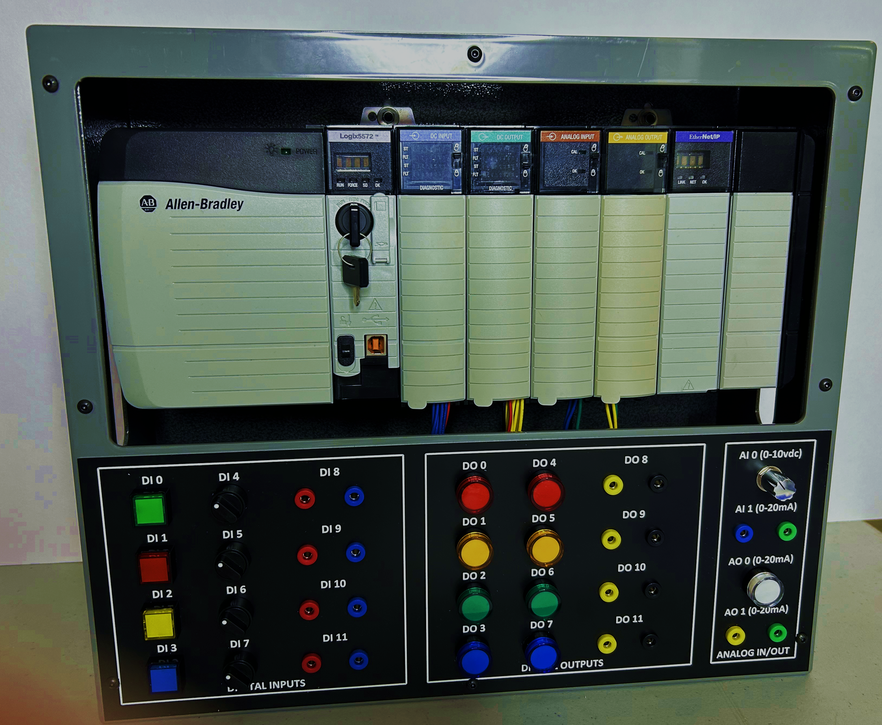
Intermediate ControlLogix® PLCs Course

Course Overview
Length: 2-days (16 hrs)
Hands-On: 75%
Target Audience: Personnel who have some basic knowledge but need to perform moderate level troubleshooting and maintenance on ControlLogix® PLC systems.
Typical attendees include: Electricians, Instrument Technicians, Automation personnel, Engineers and others who do higher level work with ControlLogix® PLC systems and/or Rockwell’s Logix series software.
Summary Description: This intermediate course bridges the gap between basic and advanced ControlLogix® courses. It covers core concepts and additional knowledge required for complex tasks and higher criticality systems. Students will engage in programming, IO and module configurations, and troubleshooting using Studio 5000 Logix software.
Note – this intermediate level course jumps right into the material and assumes students have at least a knowledge level equivalent to having recently completed our Basic ControlLogix® PLs course or equivalent.
Course Agenda:
Day 1
- Expand knowledge of ControlLogix® core concepts (scan cycle, program layout, logic functions, basic instructions).
- Navigate advanced functions (User Defined Tags, Add-on Instructions, Multi-dimensional tag arrays).
- Become familiar with program documentation, templates, and standards
- Configure and analyze digital and analog IO, including calibration procedures.
- Troubleshoot advanced program logic functions

DAY 2
- Understand alternative programming styles (ST, FBD, SFC) and advanced PLC program layout.
- Use advanced features and tools in Logix Studio software.
- Analyze and troubleshoot ControlLogix® communications and MSG instructions.
- Master advanced PLC forces and common maintenance procedures.
- Understand differences between CLX versions and integration with Logix family equipment.
- Utilize online tools, reference manuals, and support resources.
Hands-On Exercises (only major items or group titles listed):
This course includes 75% hands-on training using 7-slot ControlLogix®® racks with 1756 series processors, I/O cards, and various communications cards. The PLC racks are connected to exclusive training stations with digital and analog IO inputs and communications cards, networked on Ethernet using 1756 series Ethernet cards and switches. Students will use Rockwell Logix Studio software to program, configure, modify, analyze, and troubleshoot various problems and concepts. Key hands-on exercises of this course include:
- Hardwired relays and how it relates to Ladder Logic
- ControlLogix® series PLC components intro
- Ladder logic basics (XIC, XIO, AND/OR functionality, etc.)
- Latches & Seal logic
- Scan cycle concept basics
- Program layout, organization, & interpretation
- Common PLC procedures, precautions, tips, & tricks
- Timer & Counter basics
- PLC analog and numerical functions
- Math and Compare instructions
- Tasks, Programs, Routines
- Basics of diagnostic IO functionality
- Introduction to Status Indicators
- Basic diagnostic tools and information to troubleshoot
- Troubleshooting IO problems
- Introduction to ControlLogix® communications and network layouts
Student Outcomes (Course Objectives)
- Connect to ControlLogix® processors using RSLinx®.
- Read and interpret ladder logic programming.
- Troubleshoot common analog or digital field device problems.
- Make minor edits to PLC programs and understand potential hazards.
- Perform online data manipulations and force operations safely.
- Use Logix software effectively and troubleshoot common hardware problems.
Team / Organizational Benefits:
- Empower personnel to perform higher-level tasks with PLC systems.
- Develop future leaders and mentors for maintenance personnel.
- Enhance in-house talent to identify and resolve automation system issues.

